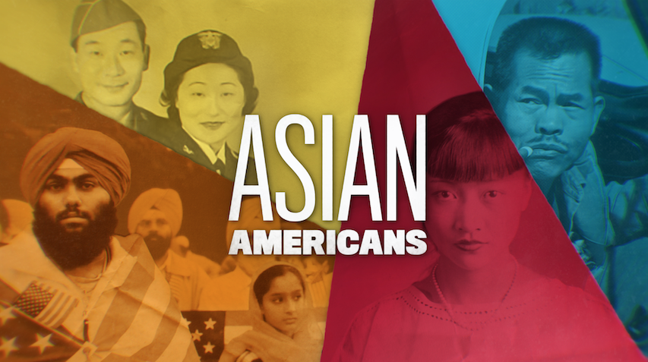

**TOPIC: The Fight For School Desegregation by Asian Americans**

**GRADES: 7-12**

**BACKGROUND ESSAY**

Following the passage of the Chinese Exclusion Act of 1882, which prohibited Chinese laborers from immigrating to the U.S., Chinese Americans were racially excluded in other ways. In California, the Tape family legally challenged the San Francisco Board of Education because their daughter was denied access to public education. This led to the 1885 landmark California Supreme Court case, *Tape v. Hurley*, one of the earliest civil rights decisions against racist policies that segregated students on the basis of race. This occurred 69 years before the U.S. Supreme Court deemed school segregation unconstitutional in *Brown v. Board of Education* (1954).

Joseph and Mary Tape were Chinese immigrants who came to California in the 1860s. When Mary was an orphan, the Ladies’ Protection and Relief Society provided her with housing and taught her English. Joseph worked as a houseboy and a dairyman in his early years, and became a successful broker. They considered themselves as American as the native-born Americans they lived amongst in San Francisco and believed their American-born daughter, Mamie should be allowed to attend Spring Valley Primary, an all-white school. The principal Jenny Hurley denied Mamie enrollment into Spring Valley because of her race. In response to this discrimination, the Tapes sued Hurley, and took it to the California Supreme Court.

School officials argued that the California Constitution stated that the Chinese were “dangerous to the well-being of the state,” and thus anyone of Chinese descent should not be admitted to San Francisco public schools. The California Supreme Court ruled in its decision that the 14th Amendment protected the rights of citizens and that the San Francisco Board of Education could not deny Mamie, a U.S. citizen, the opportunity to attend school. They did however strongly hint that segregated schools were not against the law, which led the San Francisco Board of Education to do just that - build separate schools for Chinese students. Later that year, the Tapes had no choice but to enroll their children at the Chinese Primary School, even though they continued to fight for Mamie’s right to attend an integrated school.

*Tape v. Hurley* ultimately did not win Mamie Tape the ability to attend Spring Valley Primary School or create an integrated school system that allowed all students to equitably access education regardless of race. Nevertheless, this is an important civil rights decision. Many years later, federal court case *Mendez v. Westminster* (1947), and U.S. Supreme Court case *Brown v. Board of Education* (1954), expanded on the *Tape v. Hurley* decision that all students should have access to schooling by ruling school segregation on the basis of race as unconstitutional.

**VOCABULARY**

* **Segregation:** legally separating people by race or ethnicity in an established community within various services and public spaces depending on the law
* **Civil Rights:** A set of fundamental rights for everyone, including equal treatment under the law, regardless of race, ethnicity, religion, gender, or other personal characteristics
* **Xenophobia:** fear and hatred towards a person or group of people from a foreign country

**DISCUSSION QUESTIONS**

* Why was Mamie Tape unable to enroll at a San Francisco public school?
* How were racist policies a factor in the education of Chinese American students? Explain any parallels between Mamie Tape and students of color today.
* Why do you think Mary Tape was dissatisfied with the San Francisco Board of Education’s decision to create a Chinese Primary School for Mamie to attend?

**ACTIVITIES**

***Activity 1: Analyzing a Primary Source - Mary Tape’s Letter to the San Francisco Board of Education***

Read the following excerpt of Mary Tape’s letter with students (excerpted from the “Fight Against School Segregation” film clip. Citation: Mary Tape, An Outspoken Woman, *OAH Magazine of History*, Volume 15, Issue 2, Winter 2001, Pages 17–19,<https://doi.org/10.1093/maghis/15.2.17>). Inform them that grammar and writing standards were different in the 1800s and to look for the meaning behind her words when analyzing Tape’s letter.

“To the Board of Education - Dear Sirs: I see that you are going to make all sorts of excuses to keep my child out of the Public schools. Dear sirs, Will you please to tell me! Is it a disgrace to be Born a Chinese! Didn’t God make us all!!! What right have you to bar my children out of the school because she is a Chinese Descend...I will let the world see Sir What justice there is When it is govern by the Race prejudice men! just because she is of the Chinese descend, not because she doesn’t dress like you because she does. just because she is descended of Chinese parents I guess she is more of a American than a good many of you that is going to prevent her being Educated.” - Mrs. M. Tape, April 16, 1885

Tell students to annotate the letter using a chosen strategy by the teacher.

Pair student up and have them answer the following questions:

* How does Mary Tape’s letter reveal the anti-Chinese sentiment in the United States during the 1880s? Cite evidence from her letter.
* How does Mary Tape’s letter show Mary Tape’s courage and steadfastness and represent resistance and activism? Cite evidence from her letter.

Have students share what they discussed and continue the discussion as an entire class.

***Activity 2: Research School Desegregation Cases***

Tell students that they will analyze how other legal cases against school segregation relate to *Tape v. Hurley*. They will conduct research on the following legal cases:

* *Mendez v. Westminster* (1947) - See [United States Courts “Background - Mendez v. Westminster Re-enactment” webpage](https://www.uscourts.gov/educational-resources/educational-activities/background-mendez-v-westminster-re-enactment) to guide students with initial research
* *Brown v. Board of Education* (1954) - See [United States Courts “History - Brown v. Board of Education Re-enactment” webpage](https://www.uscourts.gov/educational-resources/educational-activities/history-brown-v-board-education-re-enactment) to guide students with initial research

Other legal cases on school segregation that students can also research are: Massachusetts Supreme Court case *Roberts v. City of Boston* (1849) and U.S. Supreme Court case *Lum v. Rice* (1927)*.*

Have a class discussion on the following:

* What are the similarities and differences between *Tape v. Hurley* (1885), *Mendez v. Westminster* (1947), *Brown v. Board of Education* (1954), and any other legal cases researched?
* Explain what role each of the three cases (*Tape v. Hurley, Mendez v. Westminster,* and *Brown v. Board of Education*)play in desegregating schools? How were these cases demanding equality and social justice for all Americans?
* What are some current issues in regards to education equity in the United States?

**FURTHER INFORMATION**

* [“I Want to Go to School: The Case of Tape v. Hurley.”](http://www.chsa.org/wp-content/uploads/2010/08/Mamie-Tape-Curriculum-Guide.pdf) *Chinese Historical Society of America*.
* [“In Pursuit of Equality - Separate Is Not Equal,”](http://www.americanhistory.si.edu/brown/history/2-battleground/detail/tape-family.html) *Smithsonian National Museum of American History*.
* [“‘We Have Always Lived as Americans.’”](http://chineseamerican.nyhistory.org/we-have-always-lived-as-americans/) Chinese American: Exclusion/Inclusion – *New York Historical Society*.



[**PBSLearningMedia.org/collection/asian-americans-pbs**](https://www.pbslearningmedia.org/collection/asian-americans-pbs/)

Major Funding for ASIAN AMERICANS is provided by Corporation for Public Broadcasting (CPB); Public Broadcasting Service (PBS); Wallace H. Coulter Foundation; Ford Foundation/JustFilms; National Endowment for the Humanities; The Freeman Foundation; The Arthur Vining Davis Foundations; Carnegie Corporation of New York; Kay Family Foundation; Long Family Foundation; Spring Wang; and California Humanities.