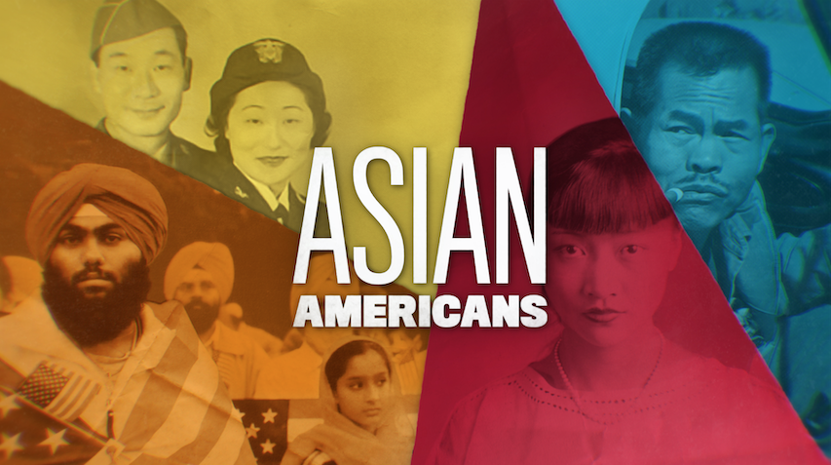

**TOPIC: Asian American Veterans and the Anti-War Movement**

**GRADES: 7-12**

**BACKGROUND ESSAY**

The U.S. was involved in the Vietnam War from the 1950s to 1975 in an effort to prevent the communist government of North Vietnam from overtaking the democratic republic of South Vietnam and creating a unified communist Vietnam. Over the years, American troops were sent to assist South Vietnam in their fight against North Vietnam. In 1962, 9,000 Americans were stationed in South Vietnam. By 1967, the number of troops overseas had grown close to 500,000, with over 15,000 killed and more than 109,000 wounded. When the war ended, over 2.5 million Americans had served in Vietnam and more than 58,000 troops died. The U.S. bombing campaign against North Vietnam and communist sympathizers in other parts of southeast Asia greatly distressed Americans. Air bombing raids began in 1964 when Congress passed the Gulf of Tonkin Resolution, and steadily increased along with military attacks on the ground.

As Americans witnessed the bombings and violent atrocities in the news and learned that it was costing billions of dollars a year in taxes, many began to question the U.S.’ involvement in Vietnam. Further, up to 40,000 American men were drafted every month, which many people opposed.

Initially, anti-war demonstrations consisted of college students who led teach-ins on campuses. Later these protests grew into large marches across the country, such as in Washington, DC. This all occurred at the height of the Civil Rights Movement.

Asian Americans drafted into the military during the Vietnam War spoke out against the war along with other veterans when they came back from their tour of duty. Japanese Americans Mike Nakayama and Scott Shimabukuro were among over 100 veterans and civilian contractors who participated in the 1971 Winter Soldier Investigation in Detroit, Michigan. This was a 3-day event in January, held by the organization Vietnam Veterans Against the War. It allowed former soldiers to give testimony about the war crimes they committed or witnessed abroad. Former Secretary of State John Kerry was a leader of this organization and testified to the Senate Foreign Relations Committee about his war experiences that same month.

In 1973, due to the strong anti-war climate in the country, President Richard M. Nixon ordered the withdrawal of American forces from Vietnam. Also, Congress passed the War Powers Act to prevent a president from involving the U.S. in an armed conflict without Congressional consent.

**VOCABULARY**

* **Communism**: ideology structured upon the ideas of common ownership and the absence of social classes, money and the state
* **Drafted:** when a group of people are selected to be required to go somewhere for a certain purpose, such as the military
* **Gulf of Tonkin Resolution:** an official written decision by Congress in 1964 that gave President Lyndon B. Johnson war-making powers, which initiated the bombing raids of North Vietnam during the Vietnam War
* **Social welfare:** services that help people living in disadvantaged situations
* **Testimony:** formal written or verbal statements that is evidence in support of fact

**DISCUSSION QUESTIONS**

* What were some reasons the American public began to question the United STates’ involvement in Vietnam and for many to oppose the war?
* Why might it be more powerful for veterans of a war to support the Anti-War Movement than non-veterans?
* Asian American veterans claim that the atrocities committed overseas were because “they tell you that the people over there aren’t really people.” How do you think they felt about this since the Vietnamese they were fighting were of Asian descent too?

**ACTIVITY**

**Activity 1:** **Beyond Vietnam**

In 1967, Dr. Martin Luther King, Jr. made his “Beyond Vietnam” speech at Riverside Church in New York City, condemning the war and addressing America’s neglect of domestic issues. Have students read and analyze Dr. King’s speech, [“Beyond Vietnam: A Time To Break Silence”](https://kinginstitute.stanford.edu/king-papers/documents/beyond-vietnam), which may be found at Stanford University’s The Martin Luther King, Jr. Research and Education Institute.

Instruct students to answer the following questions individually:

* What are some reasons Dr. King opposed the Vietnam War?
* What were America’s responsibilities to those living here in the United States?
* What did Dr. King mean when he said: “We were taking the black young men who had been crippled by our society and sending them eight thousand miles away to guarantee liberties in Southeast Asia which they had not found in southwest Georgia and East Harlem.”
* How did the United States devastate the country and people of Vietnam during the war? What was Dr. King’s view of the Vietnamese people?
* What were the five recommendations Dr. King suggested for pulling American troops out of Vietnam?

Conduct a class discussion based on their responses.

**FURTHER INFORMATION**

* [“Japanese American Vets Still Ponder the Vietnam War.”](https://www.pacificcitizen.org/japanese-american-vets-still-ponder-the-vietnam-war/) *Pacific Citizen*, Japanese American Citizens League
* “[Vietnam War Protests - Causes, Groups & Dates](https://www.history.com/topics/vietnam-war/vietnam-war-protests)” HISTORY Channel
* [“Winter Soldier,’ a Remembrance of Vietnam Atrocities”](https://www.npr.org/templates/story/story.php?storyId=4800067) NPR



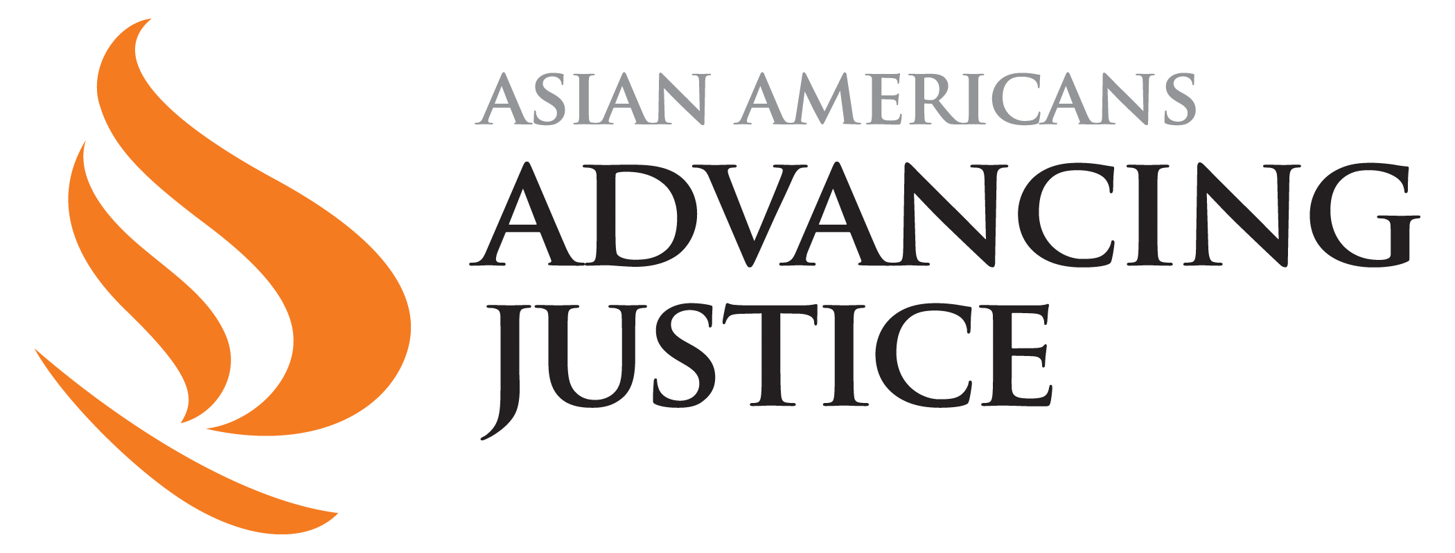



[**PBSLearningMedia.org/collection/asian-americans-pbs**](https://www.pbslearningmedia.org/collection/asian-americans-pbs/)

Major funding for Asian Americans is provided by Wallace H. Coulter Foundation; Corporation for Public Broadcasting (CPB); Public Broadcasting Service (PBS); Ford Foundation/JustFilms; National Endowment for the Humanities; The Freeman Foundation; The Arthur Vining Davis Foundations; Carnegie Corporation of New York; Kay Family Foundation; Long Family Foundation; Spring Wang; and California Humanities.